Paths of Enlightenment
by Linda Nevill

A reflection on the collaborative work Significant Walks: Personal visualisations of the chronic back pain experience. An Art, Health and Science Project 2014
by Dr Shirley Chubb, Professor Ann Moore, Dr Kambiz Saber-Sheikh and Neil Bryant.

By the time we finish school, many of us have developed the idea that we stand specifically positioned on the imaginary scale between arts and science. This stance can even become a lens through which we view our own personality – how often have you heard someone say that they don’t ‘get maths’ or that they are not ‘an arty type’?
In the 1700s, ‘the arts’ meant industry and technology, and ‘science’ meant reliable knowledge in subjects such as philosophy or theology. Distinctions were not a source of conflict. The 150 year-old history of the Two Cultures debate began in the 19th century with the rapidity of scientific advancement, and was flourishing still in 1959 when novelist and scientist C.P. Snow famously gave his Rede lecture on the subject, at Cambridge University. He described a “gulf of mutual incomprehension” and advocated an end to such estrangement, saying “the clashing point of the two subjects.....ought to produce creative chances.” (Snow in BBC 2013)
The art of science... the science of art...might such disciplines be plausible? What could such morphings of different fields of combat bring to the public arena in 2014? How would practitioners from seemingly opposing armies find collaboration productive? These questions were in the ether when I first planned to view Significant Walks, an exhibition to be seen at the Otter Gallery, University of Chichester. It has been produced by two artists, critical interventionist Dr Shirley Chubb and digital media practitioner Neil Bryant, and two health scientists, musculoskeletal physiotherapy specialist Professor Ann Moore and biomedical engineer Dr Kambiz Saber-Sheikh. The show has the subtitle Personal Visualisations of the chronic low back pain experience. An Art, Health and Science project. This references the fifth source of input for the work, 12 participants, members of the public, long-term low back pain sufferers who were found through advertising and then selected using the criteria of having a non-specific low back condition. Chubb, lead researcher, describes the essential process of the work:
“Manifested as an immersive digital artwork, a methodology has been identified that synthesizes eye-level video documentation of participants’ walks with simultaneously gathered streams of kinematic data recording the movement of the spine.” (Chubb in Sams 2013 p.51)
The work was aimed at a visual arts audience, but also at patient groups, health professionals and students. Each participant chose a significant walk where they were familiar with monitoring their back pain, and at the start of the walk, a head cam was fitted to their forehead, plus two matchbox-sized inertial sensors were taped to their spine (Figs.1 and 2). This is state-of-the-art equipment that was introduced to the project by Saber-Sheikh, Co-ordinator of The Human Movement Laboratory, University of Brighton. The sensors catch a range of movements of the spine and express express information as numerical data which was later linked with the visual footage by Bryant. He was also charged with introducing ‘After Effects’, an interpretative software package, to the volunteers. Within the group of 26 to 64 year olds, there were some less than comfortable with this, but he saw them all through selecting from a menu of special effects, and applying them where they wished in their own films.
On the day of each walk, the group must have looked an intriguing procession. In single file, walker in front, followed by the four researchers carrying laptop, phone, bottles of water, sketchpads, Moore asking every five minutes for a pain reading on a scale from one to five. All were grateful for the happenstance of sunshine for every recording.
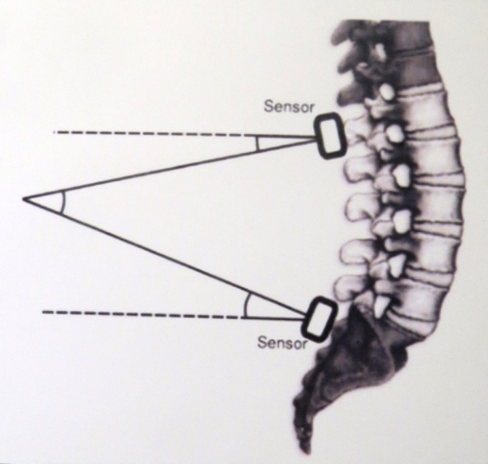 Fig.1
Fig.2
Professor Ann Moore, Head of The Centre for Health Research at the University of Brighton, has led a number of large randomised controlled trials in the area of musculoskeletal therapy. Eight out of ten of us will experience back pain at some point in our lives. If we were to be one of the unlucky ones whose condition became chronic after treatments such as structured exercise programmes; manual therapy; acupuncture and painkillers, we would have to find ways to cope with living with the pain. Sufferers also have to contend with the perception of others that their condition is an excuse to be used when convenient, over-dramatised and in the same realm as Man Flu. Significant Walks is a project that has taken notice of their pain and how it compromises their lives. By taking measurements of movement and pain during a walk of significance for each of the participants and giving them the opportunity to take part in qualitative interviews they could each simultaneously express a deeper understanding of their back pain and be creative in the process. Moore states “What I have been very interested throughout my research years in is the efficacy of treatment, but in particular, exercise as a treatment for long-term back pain .....The value of the research is that it is designed to give individuals who are experiencing chronic low back pain a voice which can impact on the work of allied work professionals as well as on members of the public....More and more we are moving into mixed methods (of research)” (Moore 2012). Teddlie and Tashakkori call this ‘the third methodological movement’, in their article Mixed Methods Research (in Denzin and Lincoln 2011 p.285) So, within the remit of the Significant Walks project, for “mixed methods” we read qualitative and quantitative interdisciplinary collaboration, and in this case for “exercise”, we read walking. Interestingly, most of the participants reported feeling relief from the walk, either because of the physical movement or because of the “meaning’’ of the chosen walk, contrary to expectations of it being a form of labour. One of them even walked barefoot to test herself.
Much of the work of international artist Shirley Chubb has centred on museums, examining the cultural and social resonance of their holdings. Her practice explores the relationship between the individual and their sense of place, considering how our experiential engagement with environments shapes our understanding of the world. She had previously worked on her video piece Thinking Path (2004/5),made for Shrewsbury Museum. It was inspired by Darwin’s favourite path that he walked every day for a period of reflection, within the grounds of The Mount, his birthplace and home. American writer Rebecca Solnit’s comment, in her noted work Wanderlust, aptly expresses Chubb’s concerns: “When you give yourself to places, they give you yourself back; the more one comes to know them, the more one seeds them with the invisible crop of memories and associations that will be waiting for you when you come back, while new places offer up new thoughts, new possibilities. Exploring the world is one of the best ways of exploring the mind, and walking travels both terrains. “ (Solnit 2002 p.12)
The visual source materials for Thinking Path prompted an interest in the mechanics of motion, as did Chubb’s own problems with lower back pain, and realising the potential of her approach as a means of conceptualising physical problems, the team of four came together, through their mutual concern with the resonance of walking as an interpretive tool. They sought an expression of the interdependence of qualitative and quantitative research, with the significance of each individual’s walk crucial to the process. Chubb explains “I work to express how space can carry meaning, seeing walking as a productive act. It is therapeutic, not therapy. My interest is in how people perceive their sense of space. Ann (Moore) is concerned with how people’s physical movement occurs within a space.....Using our methodology, we aimed to capture both clinical data and metaphysical impressions.....This is about what walking means in Ann’s field and what it means in mine. The mechanical versus the intuitive understanding of place, past, present and future.” (Chubb 2014a)
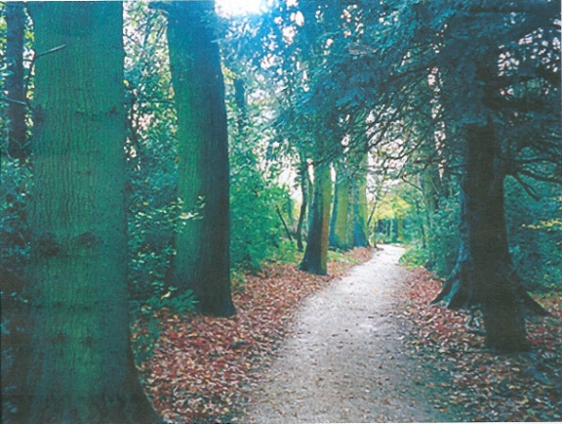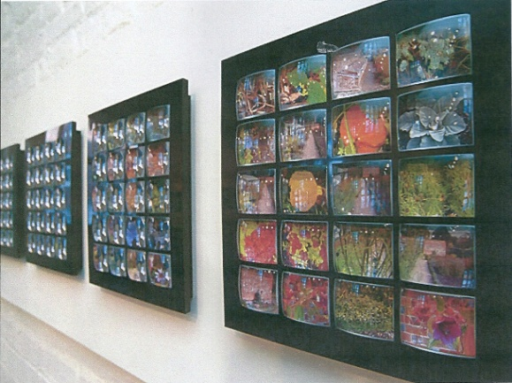
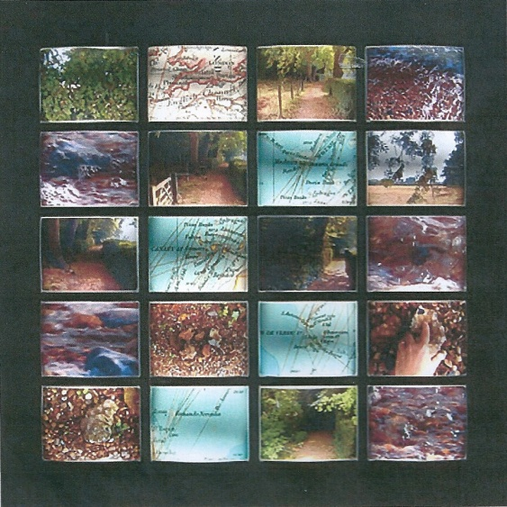
Figs 3, 4 & 5
Details from Thinking Path 2004
Shirley Chubb
Shrewsbury Museum and Art Gallery
Chubb has been a facilitator for Significant Walks, which took three years to complete. She knew that her creative input would be needed mainly near the end. She began with a successful application for funding from the Wellcome Trust, an independent global charitable health foundation. For this she was compelled to supply real accuracy in what they proposed to do – not an easy thing for an artist to articulate. Ethical approval was required as to how the data would be used and how the role of the volunteers fitted in the philosophical framework. Tenacity was needed to get the participants on board. Chubb described getting people in the right place at the right time as “like herding cats.” (Chubb 2014a) She spoke about her biggest hurdle: “I had to make a seminal shift as a practitioner as I was working with things made by someone else. I knew that it was important to keep their integrity, to resist the temptation of intervention, and respect others’ choices. Mutual trust was paramount. I experienced lots of soul-searching and self-doubt about my role and about making it more than just putting it together.” (Chubb 2014b)
Walking has been a source of inspiration and consideration for many people of the arts. Writer Bill Bryson, in his book A Walk in The Woods, describes it thus:
“...most of the time you don’t think. No point. Instead you exist in a kind of mobile Zen mode, your brain like a balloon tethered with string, accompanying but not actually part of the body below. Walking....becomes as automatic, as unremarkable as breathing.” (Bryson 1998)
The participants of Significant Walks have been robbed of this unconscious ease of motion, as a result of the constant preoccupation with their daily difficulties.
Considering the walk as a line, anthropologist Tim Ingold states “A line equals life....Lines entail movement...Lines are a way of bringing together our understanding of how we move, how we know and how we describe.” (Ingold in BBC 2015) In 1925, in his Pedagogical Sketchbook, artist Paul Klee spoke of “the wandering, moving, dynamic line” and proposed “taking a line for a walk”. (Ketteridge in BBC 2015). I clearly remember being given this exact instruction in my primary school art lessons. Klee and I were using standard drawing materials. Other artists used the more unconventional. For example, found rocks (Richard Long), household paint (Susan Stockwell), and blood (Franko B). Regina Jose Galindo dipped her feet in blood to take a symbolic walk, in front of a heavily guarded government building in Guatemala City, leaving a trail of bloody footprints. In their famous performance piece The Lovers-The Great Wall Walk, 1988, Marina Abramovic and Ulay walked towards each other from either end of a pre-existing man-made line, the Great Wall of China. All of these practitioners challenged assumptions about the nature of art by making sculpture from a walk, taking that genre into the domain of the immaterial; a walk comprises the movement of the body through time and space, with phenomenological attributes of a 3D and 360 degree nature, as a traditional sculpture would, and more. Perhaps walking artist Hamish Fulton sums up the conviction of all who work in this genre when he says “An object cannot compete with an experience.” (Fulton in Tufnell, B. Fulton, A. 2002 p.108)
Poet, artist and film-maker Imtiaz Dharker discusses the line in poetry: “It goes on a kind of walk. It has feet and it can get into its own stride. ...In a poem, it’s the wideness at the end of a line that’s as important as the line itself.....Time stops and takes a breath or pauses to admire a particular word or decides to turn the corner to the next line or the next verse. The line, for me, has always been about black on white, a mark on emptiness, presence on absence, the human voice on silence, footprints in the snow.”(Dharker in BBC 2015) Dharker considers the walk of life in her poetry:
Yes, I do feel like a visitor,
a tourist in this world
that I once made.
I rarely talk,
except to ask the way,
distrusting my interpreters,
tired out by the babble
of what they did not say.
I walk around through battered streets,
distinctly lost,
looking for landmarks
from another, promised past.

Here, in this strange place,
in a disjointed time,
I am nothing but a space
that sometimes has to fill.
Images invade me.
Picture postcards overlap my empty face
demanding to be stamped and sent. From Postcards from God 1 (Dharker 1994)

The Otter Gallery is the ubiquitous white cube, except for a large alcove that makes it in truth L shaped. The ceiling is quite low, and one wall is all glass, looking onto the university’s library concourse. A blank canvas, a utilitarian space, yet redolent with the hope, inspiration, perspiration, and intent of a constant flow of exhibitions. As I enter, I notice the lighting has been lowered, bringing my eyes immediately to the brightness of a floor-to-ceiling video installation. The empty gallery affords a particular environment for personal engagement, so I sit down to watch, pencil and paper ready to record the rapid stream of my thoughts as I do so:
A grid of 9 rectangles each showing different walk. Which shall I look at? My eyes dart from one to another. Landscape, cityscape, pointing hands, a Dalmatian dog. Watch one screen only, or view the whole as one squirming snakes and ladders board?
Blur my focus...jewels of colour move, dance. I have a cardboard tube with a rotating end in my childish hand. Looking down tube, jewels fall into ever-changing patterns as I turn the end.
The Thomas Crown Affair 1968, first time I saw split-screen editing. Faye Dunaway, Steve McQueen. The cut moquette of cinema seat makes back of my teenage legs itch. Refocus. Just as one rectangle catches my attention, another moves, brighter, keener, takes my eye away. Like watching pools of bubbling mud in Rotorua, New Zealand. Where will next burst of steam occur? Paths.... Lines..... Destinies.... Symbolism of personal journeys.
Fade into one screen.
Walk 1 Immediate. Inclusive. My body is in this. My eyes are walker’s eyes. Suburban street; walking next to busy road. Shadow of walker on pavement reveals headcam. A shadow of her former self. Each step, black smudge on screen, like a veil across eyes. Pain affects her outlook. ‘Alive’ writ large on road, as if an instruction to herself and all traffic. A statement of defiance against her condition. She feels more alive out walking.
Fade to Grid of 9. Literal and metaphorical alignment of different videos in a rigid form.
Walk 2 Country scene. Ginger overlay, like sepia – old fashioned, history. Memories implied. Trees appear to jump up and down- jolting walking style. To a green path, green overlay, green horizon of bushes and trees that bump around like an ambling stegosaurus. Blitzkrieg. Shells going off. Explosions of pain.
Fade to Grid of 9. My eye is always caught by the red rectangle. Of the body.
Walk 3 Tree- lined path from university to town. Tiny points of white light flash centre screen on each step. Piercing niggle of pain, there, but not all-encompassing. Yet possible flipside -spirit; life force; courage of walker. My focus held where walker’s is, looking down on centre path. Enforced introspection.
Fade to Grid of 9. A patchwork of experience. A moving quilt stitched together by empathy.
Walk 4 Beautiful tall white flowers line a country path. Just out of focus, just out of reach, struggle to fully engage. Vision sways with exaggerated gait. Throbbing pulse. Bursts of radiating light. A path of enlightenment.
Fade to Grid of 9. Convergence.
Walk 5 Street scene. Following a young girl. Distortion; nausea; confusion. Andy Warhol style changing of colours. Pain warping encounter. Shapes become blocks of colour, then blend into sketched outline, no solid form. Becomes a plan, a map to be navigated. Walk is narrowed to a reduced experience, a 2D experience.
Fade to Grid of 9. Linking. Merging.
Walk 6 Green South Downs open scenery. A worn path in grass. Path of Desire. Layering of one horizon shot over another, but at different angles. Dalmatian dog prances easily along in front, as if to highlight owner’s difficulties by comparison.
Fade to Grid of 9
Walk 7 A concrete pathway within the university campus. Narrowing to tunnel effect on pulse of each step. Focus streaked with light, like lights refracted from a solitaire diamond. Multi facets of pain. Enter a classroom, learn and understand through fog.
Fade to Grid of 9
Walk 8 Bucolic countryside scene slashed by sharp diagonals of white light. Tunnel vision brings attention to path. Concentration required to manage walk while in pain. Loneliness of the long-term sufferer.
Fade to Grid of 9
Walk 9 Suburban residential street. Horizon moves from left to right emphasising the struggle of gait. Deliberate and slow. A pulsing red haze. Implied stress in contrast to normality/ banality of surroundings.
(Another gallery visitor walks across screen and briefly becomes a black figure participating in walk)
Fade to Grid of 9
Walk 10 Country path through woods into meadows. Hand of walker in shot, pointing out features, direction, familiar spots. Swaying, merging, overlaying of one part of walk to another. Orange- red earth of path – fire walking. Hot coals underfoot. Colour in strong contrast with surrounding green (ref colour wheel) Highlights pain of walking the line.
‘I keep a close watch on this heart of mine
I keep my eyes wide open all the time
I keep the ends out for the tie that binds
Because you’re mine
I walk the line’ (Johnny Cash)
Fade to Grid of 9
Walk 11 Woodland walk. Border collie walking ahead, looking back. “Come on....keep up.” Another orange- red path through deep woods of indigo blue. All dappled with sunlight. Poetics of the path. Pastoral idyll, then drains of colour to greys. Loss of full enjoyment, loss of headspace to appreciate surroundings while hurting.
Fade to Grid of 9
Walk 12 Country path. Focus blurring on each step. Tiring, pain is wearing. Becomes more and more distorted with each step.
Return to loop. The grinding relentlessness of continuing pain.
Fig. 6
Video installation Significant Walks
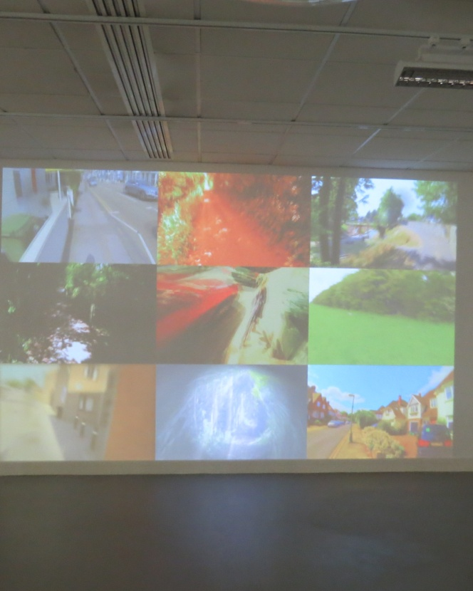
Talking about the making of this piece, Chubb says “Scale was very important. It had to be life-size so that the viewer could feel part of the film. I chose not to have a soundtrack, as I wanted full focus on the visual. The viewer being in an internal space, looking at external footage, reflects the methodology of inside and out. I have used split screens and grids before, so they appealed, as did the expression of liminality and interstitial space through layering and undefined edges.“ (Chubb 2014b) She explained that she had been limited by the format of the film which only allowed a grid of nine rectangles. Twelve would have made each section like a lozenge. As it was vital to give each participant equal amounts of time within the film, despite her own artistic preferences, she had to accommodate them within the sections on a roll-up system. Placement was also influenced by patterning: ‘urban; rural; urban; rural,’ and ‘effects; no effects.’
Urban and rural are environments relevant to Ingold’s proposal that there are two ways of walking: navigating and wayfaring. The former, described with urban surroundings, is conducted in the maze which “encloses, trapping its inmates within the false antimony of freedom and necessity” (Ingold 2013 p.9) The latter, described with a rural backdrop, takes place in the labyrinth, where “there is no point of arrival, no final destination, for every place is already on the way to somewhere else.” Navigating is intentional; wayfaring is attentional. “As intention is to attention....so absence is to presence.” (Ingold 2013 p.8) I believe that Ingold means that we place ourselves in metaphysical mazes or labyrinths by our own outlook. It is up to us to decide how we travel, and that we have the power to change whatever philosophical landscape we find ourselves in.
As French philosopher Merleau-Ponty declares: “The world is not what I think, but what I live through.” (in Parry 2011 p.6) The personal walks of the sufferers included in this installation clearly illustrate this statement by demonstrating how their long-term conditions change their world. The experience of their bodies within their films and the engagement of the viewer’s body with the finished artwork makes for a potent encounter. Something about the lens is very akin to the human consciousness which looks out at the universe. Film has unique ways of detaching us from our natural perceptions and turning us into phenomenological spectators. Parry elaborates: “Films do not simply reflect reality, like a mirror; they reflect on reality, understood as a phenomenon. The character of factual existence does appear in film, as it does in phenomenology, but in brackets, as a phenomenon created by the filmmaker’s reflection and offered to the viewer’s reflection.” (Parry 2011 p.195)
For me, Nietzche precisely described Chubb and Bryant’s additional purpose in the work when he wrote: “only artists...have given men eyes and ears to see and hear...what each himself is, himself experiences, himself wants; only they have taught us to value the hero that is hidden in each of these characters and taught the art of regarding oneself as a hero.” (Nietzche in Parry 2011 p.10) Hopefully, the participants have been able to derive this well-deserved boost.
On the left wall of the gallery hangs a large rectangular work on white paper. It is covered in columns of numbers. A physical manifestation of the data sent by the spine sensors fixed to the participants. It brought thoughts of ancient stone tablets inscribed in languages that are a mystery to me, needing translation. Another visitor to the gallery was studying the work for some time. I asked her what was intriguing her. She replied that she was looking for patterns within the numbers. None were found but we both became aware of the rhythm of the data, a different angle of interpretation. Chubb revealed in her gallery talk that some male volunteers had wanted to see numerical data in the large video, but she vetoed this very firmly. It did not fit with her artistic vision.
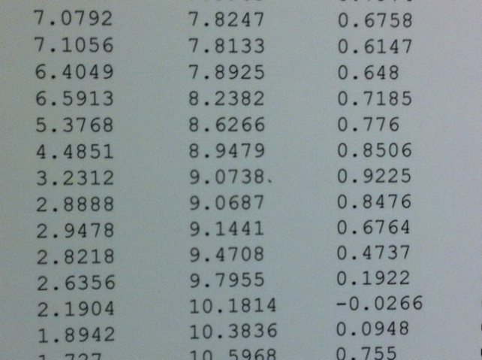
Fig. 7 Data stream (detail) from
Significant Walks 2014
In the alcove of the gallery is a smaller video presentation. It intersperses statements from the walkers, diagrams of the physiology of movement indicating transverse and coronal planes, and sequences of geometric shapes that pulse and vibrate. These shapes dazzle the eyes, and the viewer is obliged to screw up their eyes as you would when feeling pain. The statements give insight into how the volunteers’ conditions change their psyche. I noticed “Makes me feel old before my time.” For me, this piece has the sense of medical information, whilst still having an emotional element. The science feels more evident in this art.
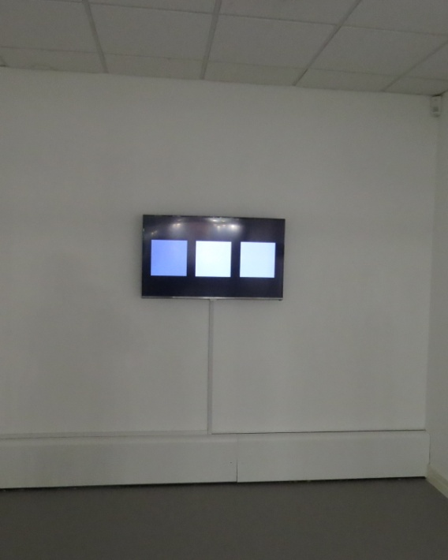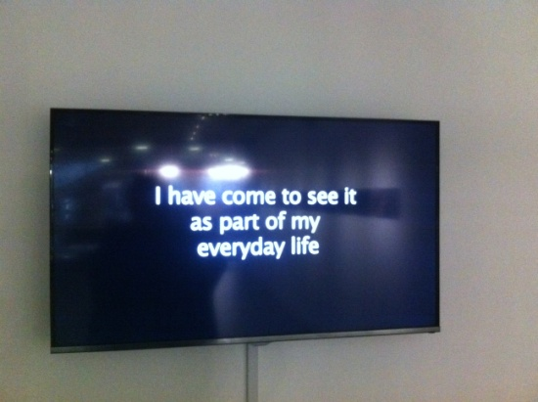
Figs 8 and 9 Small video installation

Small video installation
Also included in the show is a normal-sized computer monitor, showing the films of the participants’ walks in a 12-rectangle grid. By sitting down and clicking on the rectangle of their choice, the visitor can engage in a more intimate viewing of an individual film.
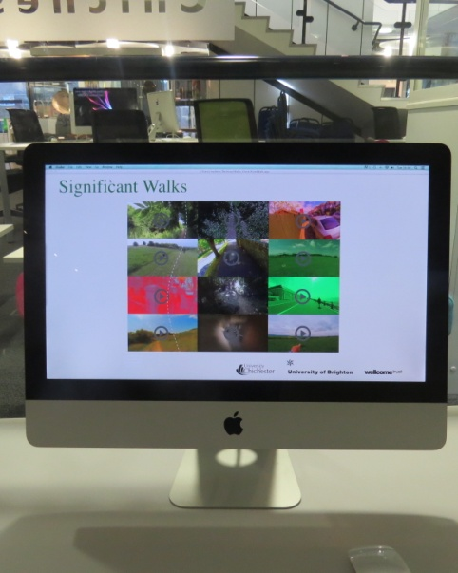
Fig. 10 Monitor for personal engagement with individual films.

Finally, on the right hand wall are a line of individual stills, one from each of the participants’ films. Chubb selected these and says ”They are an expression of tension between the very normal and the particular and personal. I chose to arrange them in a long line like a strip of film.” (Chubb 2014b) The use of Duraspec, reverse mounting the pictures and sandwiching them between two sheets of Perspex, created a glossy finish reminiscent of the surface of celluloid. Chubb made observations as she worked with the stills: “Unexpectedly, they became painterly, speaking of the traditions of landscape.” (Chubb 2014a) She cited the inspiration of Turner and The Impressionists in their ability to capture the moment, Bruce Nauman for how he explores a space, and the vast emotive quasi-spiritual video installations of Bill Viola. She also referenced the delicate, contemplative paintings of Agnes Martin as being her ‘desert island’ artworks. Built around the grid, they have no narrative and require the viewer to be predisposed to see what is and what is not present, a spiritual otherness.

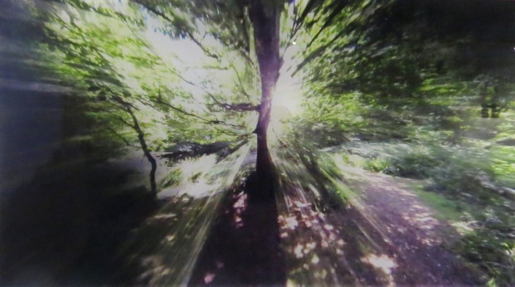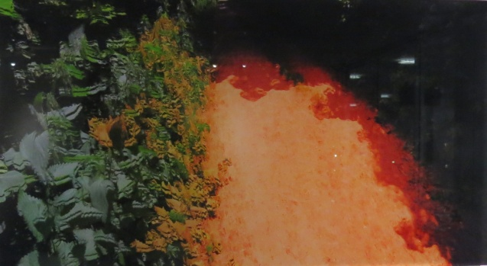
Figs. 11 and 12 Examples of stills from Significant Walks 2014

To return to the question of collaboration between arts and science, it is clear that many issues of common humanity and social process are cross-curricula and those are better addressed through the working together of scholars from both areas. It is also clear that a successful collaboration is dependent on the tolerant personalities of those collaborating, and is probably not for all. Speaking from an artist’s point of view, I agree with writer Susan Cain’s comments on problems that artists could encounter, given that many seek time alone to work: “Checking too often with someone else – pausing for feedback with each bit of output – can inhibit or confuse us. We can lose our natural trajectory, intuition or instinctual aim...Exposure to other people’s reactions can be so obfuscatory that we lose hold of our convictions and can no longer see our work clearly.” (Cain in Kelly 2012 p.2) It seems that Bryant, Chubb, Moore and Saber-Sheikh have risen above such things and have faced any issues with flexibility and determination to see it through.
Artist Marc Quinn and geneticist Sir John Sulston collaborated in the making of a portrait of Sulston in 2011. When asked later if that collaboration had changed his attitude to Sulston’s discipline, Quinn replied “I still think science is looking for answers and art is looking for questions.” (Quinn in Jeffries 2011) For me this is the key – both sides are seeking. In both areas genius lies in the ability to think outside the box. To make mental leaps and connections between disparate concepts, regardless of whether those concepts are numbers or colours. Technology reporter and TV pundit Maggie Philbin sees collaboration as commonplace and necessary, and hopes for a nation of polymaths. She comments: “The last time I looked, art, science, technology and engineering were completely enmeshed. From the music industry, to medicine, to media, to the design of buildings, fabrics and cereal packets. The arts don’t just prettify technology, they drive and embody innovation. It’s unhelpful and confusing to deem one more important than the other when they are inextricably connected with profoundly important interactions.” (Philbin 2013)
Significant Walks is a project still evolving. Much thoughtful, reflective feedback was received from the volunteers, making a body of spoken and written comment that will feed back into the work. The collaborators are still tweaking and adapting, and are looking to see the film in other environments such as waiting rooms and stations. It has gone a long way to bring home the pervading nature of lower back pain, allowing the self-expression of The Twelve, and having the potential to help many other sufferers. Ingold encourages and advises us all on how to walk:
The farer in the labyrinth....can keep on going, without beginning or end, pushing out into the flux of things. He is ...truly present in the present. The price of such presence is vulnerability, but its reward is an understanding founded on immediate experience, that goes beyond knowledge. It is an understanding on the way to truth.” (Ingold 2013 p.11)
Bibliography
Bryson, B. (1998) A Walk in The Woods: Rediscovering America on the Appalachian Trail. London: Black Swan
Crowther, P. (2009) Phenomenology of The Visual Arts (even the frame). Stanford, California: Stanford University Press
Denzin, N, Lincoln, Y. (eds) (2011) The Sage Handbook of Qualitative Research. London: Sage Publications Ltd.
Evans, D. (ed) (2012) The Art of Walking, a field guide. London, Black Dog
The Eye series DVD (2006) Hamish Fulton: Eyes, Feet, Road Illuminations
Ingold, T (ed) (1995) Companion Encyclopedia of Anthropology. Humanity, Culture and Social Life. London/New York: Routledge
(2000). The Perception of the Environment. Essays on Livelihood, Dwelling and Skill. Oxon, Routledge
(2007) Lines, a brief history Oxon, Routledge
(2011) Being Alive. Essays on Movement, Knowledge and Description Oxon, Routledge
(2013) The Maze and The Labyrinth: Walking and the Education of Attention in, Walk-On: Forty Years of Art Walking – From Richard Long to Janet Cardiff. Northern Gallery for Contemporary Art Sunderland: Art Editions North
Long, R. (2002) Walking the Line London: Thames and Hudson
Parry, J. (ed) (2011) Art and Phenomenology London/New York, Routledge
Rifkin, N. (2002) Agnes Martin: The Nineties and Beyond The Menil Collection, Houston: Hatje Cantz
Sams, L. (2013) Selected Essays from On Walking Conference Sunderland: Art Edition North
Solnit, R. (2002) Wanderlust: A History of Walking London: Verso
(2006) A Field Guide to Getting Lost Edinburgh: Canongate
Tufnell, B. Wilson, A. (2002) Hamish Fulton. Walking Journey. London: Tate
Webography
www.blackswan.com/creativity-vs-logic-art-vs-science-left-brain-vs-right-brain/ Accessed 30th December 2014
CREST (2014) Negotiating Practice in Being Human. A Festival of the Humanities. 21st November at www.crest.ac.uk/events/neotiating-practice/ Accessed 7th January 2015
Dharker, I. (1994) Postcards from God 1 at www.imtiazdharker.com/poems
Accessed 3rd January 2015
Jeffries, S. (2011) When two tribes meet: collaborations between artists and scientists in The Guardian Sunday 21st August at
www.theguardian.com/artanddesign/2011/aug21/collaborations-between-artists-and-scientists Accessed 7th January 2015
Kelly, M. (2012) Does Artistic Collaboration Ever Work? in The Atlantic July 25th at www.theatlantic.com/entertainment/archive/2012/07/does-artistic-collaboration-ever-work/260319 Accessed 7th January 2015
www.significantwalks.com Accessed 19th December 2014
www.spine-health.com Accessed 1/1/2015
Philbin, M. (2013) The Art v Science Debate: Your Views in The Evening Standard 16th May at www.standard.co.uk/comment/the-art-v-science-debate-your-views-8619504.html Accessed 1st January 2015
www.theguardian.com/education/2008/apr/11/highereducation.comment
Accessed 31st December 2014
www.wellcome.ac.uk Accessed 1st November 2014
www.the-road-north.blogspot.co.uk Accessed 31st December 2014
Videos
Moore, A (2012) Transforming Research: Building the evidence base for musculo-skeletal research at www.youtube.com/watch?v=TMzfJGF_-v4
Accessed 6th January 2015

Radio Broadcasts
BBC (2013) The Value of Culture – Two Cultures 2nd January:Radio 4 iplayer Accessed 4th January 2015
BBC (2015) The Forum - Lines 3rd January :Radio 4 live

Gallery Discussions attended
Chubb, S. and Falcini, A. (2014a) Collaboration, digital technologies and site specific practices. 28th November, Otter Gallery, University of Chichester
Chubb, S. (2014b) Significant Walks research project. 11th December. Otter Gallery, University of Chichester

List of Illustrations
Fig. 1 How spine sensors work. Print and diagram, Significant Walks 2014
Fig.2 How spine sensors are attached. Photograph: Kambiz Saber-Sheikh, The Human Movement Laboratory, University of Brighton
Fig. 3 The Sand Walk 2003 Down House, Kent. Photograph: Shirley Chubb by permission of English Heritage
Fig. 4 Thinking Path (detail) 2004 Glass lenses, polypropylene and digital prints. Shrewsbury Museum and Art Gallery
Fig. 5 Beagle Journey 02.10.1836/2003 7,203 glass lenses, polypropylene and digital prints 25 x 26cms
Fig. 6 Significant Walks 2014 Video installation 1
Fig. 7 Significant Walks 2014 Data stream (detail), Print on paper
Fig. 8 Significant Walks 2014 Video installation 2. 92 x 54cms
Fig. 9 Significant Walks 2014 Video installation 2(detail) 92 x 54cms
Fig. 10 Significant Walks 2014 Video installation 3 50 x 40cms
Fig. 11 Significant Walks 2014 (detail) Still from video 1. Duraspec mounted
Fig. 12 Significant Walks 2014 (detail) Still from video 1. Duraspec mounted

